Commercial Package Policy (CPP) can be made up of the following:
- Commercial Property
- Commercial General Liability - Commercial General Liability subline only (with or without Liquor)
- Commercial Inland Marine
- Commercial Crime
The package does not have to include all of these products. It can include any combination that works for the customer’s needs.
The dec and quote for CPP does not vary in the sections that are specific to each product (where blankets, or coverages are shown.) The areas impacted for CPP are all of the “common” sections because in some cases these needed to be modified to show each product’s items. (And some were not altered.)
A section that is changed is in the policy information. Only a package policy can be written as a “36 month” policy. This means the rates are stable during this 3-year period. However, the policy still “renews” on a 12 month cycle. So the effective date of the policy is still 12 months. We also show the customer where they are in their 3 year cycle, so they know when to be talking to their agent about the upcoming renewal.
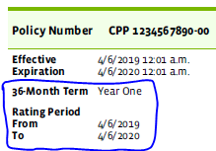
A section that was NOT changed is the Coverage Parts and Premiums table. We simply retrieve more data for this table from more places in the data for CPP.
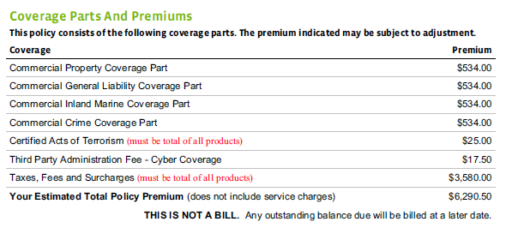
The Schedule of Locations table data is sourced from one place in the payload. PC sends us a de-duped list of locations across all products on the policy:
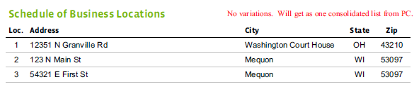
The Mortgagee and Additional Interests section can have duplicate entries across the products and this was decided to be correct behavior by the product specialists.
Order in which the product coverages should be shown: Property (F), GL (GLA), Inland Marine (IM), Crime (SCP). (This is the order from the legacy system and they wanted to maintain this.) The order is based on their product symbols: F, GLA, IM, SCP
The Policy Forms and Endorsements section is broken out into groupings for the line level forms and then the forms per product are also grouped.
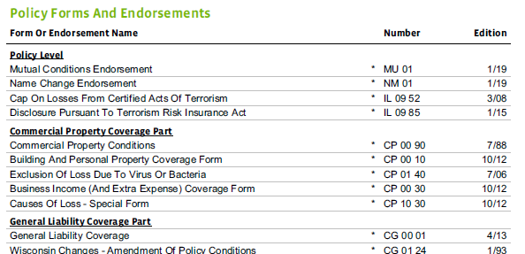
The KY Tax charges are also grouped by product. Currently, KY is the only state that requires insurers to disclose the state/county/city taxes charged on their policy. Each location on each product is considered when deciding whether not a tax needs to be charged. (Not all counties/cities have a tax.) This is all handled by rating. These taxes apply to ALL PRODUCTS – not just the CPP products.
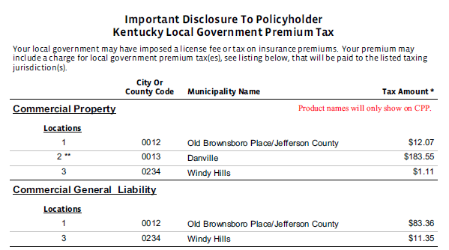
The Underwriting questions on the applications are also grouped by product. In the case of IM, they are also broken out by coverage part.
